PT Activity: Convert a Serial Link to a Site-to-Site IPsec VPN
Topology Diagram
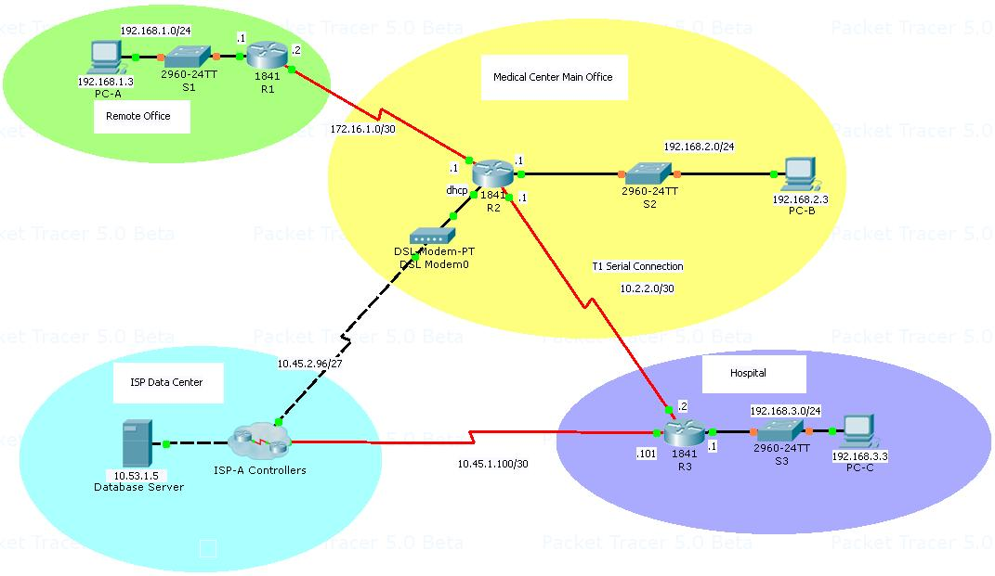
Addressing Table
Device | Interface | IP Address | Subnet Mask
R1 | Fa0/0 | 192.168.1.1 | 255.255.255.0
R1 | S0/0/0 | 172.16.1.2 | 255.255.255.252
R2 | S0/0/0 | 172.16.1.1 | 255.255.255.252
R2 | Fa0/0 | 192.168.2.1 | 255.255.255.0
R2 | S0/0/1 | 10.2.2.1 | 255.255.255.252
R3 | S0/0/0 | 10.45.1.101 | 255.255.255.252
R3 | S0/0/1 | 10.2.2.2 | 255.255.255.252
R3 | Fa0/0 | 192.168.3.1 | 255.255.255.0
PC-A | NIC | 192.168.1.3 | 255.255.255.0
PC-B | NIC | 192.168.2.3 | 255.255.255.0
PC-C | NIC | 192.168.3.3 | 255.255.255.0
ISP-A Controllers | Serial Network | 10.45.1.102 | 255.255.255.252
ISP-A Controllers | DSL Network | 10.45.2.102 | 255.255.255.224
ISP-A Controllers | Local Ethernet | 10.53.1.1 | 255.255.255.224
ISP-A Database Server | NIC | 10.53.1.5 | 255.255.255.224
Learning Objectives
- Verify connectivity throughout the network.
- Eliminate the serial connection between the Hospital and the Medical Center.
- Configure router R1 to support a site-to-site IPsec VPN with R3.
Scenario
One of the advantages to high speed broadband connectivity is that it can replace more expensive technologies, such as point-to-point serial T1 connections. When combined with an IPsec VPN tunnel, broadband can provide a secure, always-on connection between two locations. In this scenario, a medical clinic has leased space in its remote office to a radiology practice. The radiologist must have secure connectivity with the hospital to exchange images and to transfer patient information. A T1 serial connection provides that access now, but the costs are becoming prohibitive.
The hospital IT department suggested that the Medical Center configure an IPsec site-to-site VPN tunnel between the remote office router and a router located in the hospital radiology department. The hospital IT technician sent the IPsec configuration parameters to the Medical Center and has already configured the router R3 to make the connection.
The network topology shows the three routers. Your task is to disconnect the serial link between the Medical Center router (R2) as it will not be needed once the VPN is set up. Then configure router R1 to support a site-to-site IPsec VPN when traffic flows between the remote office LAN and the hospital LAN. The IPsec VPN tunnel is from router R1 to router R3 via R2 and the ISP network. Both R2 and the ISP data center act as a pass-through and have no knowledge of the VPN. IPsec provides secure transmission of sensitive information over unprotected networks such as the Internet. IPsec acts at the network layer, protecting and authenticating IP packets between participating IPsec devices (peers), such as Cisco routers.
Review the VPN Configuration Overview Document for more information.

Hospital provided ISAKMP Phase 1 Policy Parameters
Parameters |  | R1 | R3
Key distribution method | Manual or ISAKMP | ISAKMP | ISAKMP
Encryption algorithm | DES, 3DES, or AES | AES | AES
Hash algorithm | MD5 or SHA-1 | SHA-1 | SHA-1
Authentication method | Pre-shared keys or RSA | pre-share | pre-share
Key exchange | DH Group 1, 2, or 5 | DH 2 | DH 2
IKE SA Lifetime | 86400 seconds or less | 86400 | 86400
ISAKMP Key |  | vpnpa55 | vpnpa55
Note: Bolded parameters are defaults. Only unbolded parameters have to be explicitly configured.
IPsec Phase 2 Policy Parameters
Parameters | R1 | R3
Transform Set | VPN-SET | VPN-SET
Peer Hostname | R3 | R1
Peer IP Address | 172.16.1.2 | 10.45.1.101
Network to be encrypted | 192.168.1.0/24 | 192.168.3.0/24
Crypto Map name | VPN-MAP | VPN-MAP
SA Establishment | ipsec-isakmp | ipsec-isakmp
The routers have been pre-configured with the following:
• Password for console line: ciscoconpa55
• Password for vty lines: ciscovtypa55
• Enable password: ciscoenpa55
• RIP version 2

- Examine the VPN Configuration on R3
- Display the running configuration on R3.
Locate the lines in the configuration that start with the command crypto. These commands set the ISAKMP and IPSec parameters that are used by the site-to-site VPN.
Commands to set the ISAKMP policy to use AES encryption, pre-shared key authentication and DH group 2 key exchange.
crypto isakmp policy 10
encryption aes
authentication pre-share
group 2
!

Command to set the pre-shared key to use with peer 172.16.1.2

crypto isakmp key vpnpa55 address 172.16.1.2
!

Command to set the IPsec parameters.

crypto ipsec transform-set VPN-SET esp-3des esp-sha-hmac
!

Commands to bind the parameters together.

crypto map VPN-MAP 10 ipsec-isakmp
set peer 172.16.1.2
set transform-set VPN-SET
match address 110
!
Step 2. Locate the access-list 110 command.

This access list defines the LAN traffic that will be to use the VPN. This access list must be configured before creating the crypto map entry. On router R3, the access list 110 identifies traffic to the remote office LAN. Whenever a host on the hospital LAN initiates traffic to an address on the remote office LAN, the traffic will use the VPN tunnel. All other traffic will not use the VPN tunnel and will not be encrypted.
access-list 110 permit ip 192.168.3.0 0.0.0.255 192.168.1.0 0.0.0.255

Step 3. Determine which R3 interface address is connected to the ISP data center.
The VPN connection to the remote office will use this interface IP address as one endpoint of the VPN tunnel. Note the IP address of the interface, this will be the peer address you need to specify when you configure router R1.
IP Address: _____________________________________________________
Step 4. Delete the serial link between router R2 and R3.
The high-cost serial link between the medical center and the hospital will not be needed once the VPN tunnel is active between the two sites. Disconnect the serial cable and use the shutdown command on the interface connecting R3 to R2.

Step 5. Prepare router R3 to use the new VPN connection.
Activate the IPSec-ISAKMP map on the R3 interface that connects to the ISP. Use the command crypto map VPN-MAP at the interface configuration mode prompt and observe that ISAKMP is now set to ON.
R3(config)#interface s0/0/0
R3(config-if)#crypto map VPN-MAP
*Jan 3 07:16:26.785: %CRYPTO-6-ISAKMP_ON_OFF: ISAKMP is ON

- Configure IPsec parameters on R1
Step 1. Test connectivity.
Use the PING command to verify that router R1 can reach router R3 through router R2 and the ISP connection. A VPN tunnel cannot be created if the two endpoint routers (R1 and R3) cannot communicate with each other through the various networks.
- Identify interesting traffic on R1.
Configure ACL 110 to identify the traffic from the LAN on R1 to the LAN on R3 as interesting. This interesting traffic will trigger the IPsec VPN to be implemented whenever there is traffic between R1 to R3 LANs. All other traffic sourced from the LANs will not be encrypted. Remember that due to the implicit deny all, there is no need to configure a deny any any statement. Note that this access list is similar to the access list configured on router R3.
access-list 110 permit ip 192.168.1.0 0.0.0.255 192.168.3.0 0.0.0.255
- Configure the ISAKMP Phase 1 properties on R1.
Configure the crypto ISAKMP policy 10 properties on R1 along with the shared crypto key vpnpa55. Refer to the ISAKMP Phase 1 table for the specific parameters to configure. Default values do not have to be configured therefore only the encryption, key exchange method, and DH method must be configured. Use the configuration on R3 as an example.
- Configure the ISAKMP Phase 2 properties on R1.
Create the transform-set VPN-SET to use esp-aes and esp-sha-hmac. Then create the crypto map VPN-MAP that binds all of the Phase 2 parameters together. Use sequence number 10 and identify it as an ipsec-isakmp map.
- Configure the crypto map on the outgoing interface.
Finally, bind the VPN-MAP crypto map to the outgoing Serial 0/0/0 interface. Note: This is not graded.
R1(config)# interface S0/0/0
R1(config-if)# crypto map VPN-MAP
- Verify the IPsec VPN
Step 1. Verify the tunnel prior to interesting traffic.
Issue the show crypto ipsec sa command on R1. Notice that the number of packets encapsulated, encrypted, decapsulated and decrypted are all set to 0.
Step 2. Create interesting traffic.
From PC-A, ping PC-C.
Step 3. Verify the tunnel after interesting traffic.
On R1, re-issue the show crypto ipsec sa command. Now notice that the number of packets is more than 0 indicating that the IPsec VPN tunnel is working.
Step 4. Create uninteresting traffic.
From PC-A, ping PC-B.
Step 5. Verify the tunnel.
On R1, re-issue the show crypto ipsec sa command. Finally, notice that the number of packets has not changed verifying that uninteresting traffic is not encrypted.
Step 6. Check results.
Your completion percentage should be 100%. Click Check Results to see feedback and verification of which required components have been completed.

